**Name:** John Patrick F. Narvasa

**Section/Schedule:** 1 BSCS-2 / 4PM-7PM

**Program:** BS Computer Science

**Course:** Data Structures and Algorithms

**Problem:**

**Goal:** To understand Big O Notation and apply Big O Notation to analyze the time complexity of a simple algorithm.

**Problem to Solve:**

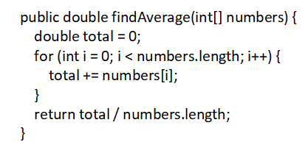

**Answer:**

**Function:** findAverage(int[] numbers)

**Time Complexity:** O(n)

**Reasoning:** The method has a single loop that iterates through each element of the array exactly once to calculate the total sum of the grades which performs a linear operation (O(n)). After the loop, the average is computed by dividing the total by the number of elements which are run in a constant time operation (O(1)). Therefore, the overall time complexity of the findAverage method is O(n) where n is the number of elements in the input array that is being iterated by a single loop.